1. INTRODUCTION

**“ONLINE QUIZ”** is an application developed in java. This application will be used for conducting online examination or test. It will be used for student progress evaluation using modern technology. It replaced the paperwork and overcomes of traditional way of examinations using paper or pen. Online Quiz application is fully developed automated system to evaluate the candidate progress that not only save the time of Examination Controller also gives fast results. Providing an online comprehensive solution to manage quiz system where the students will test their domain knowledge with respect to the particular technology.

1. **OBJECTIVES**

The main aim is to facilitate a user friendly environment and reduce manual effort of taking offline examination. It provides a common platform to connect student and teacher online. The registered teacher can create quiz and student can take quiz and can access himself/herself.

And in the end of the exam student will be given a certificate of passing the test.

Users of the System

Teacher

Student

.

1. **SYSTEM ANALYSIS**

## Existing System

There are various QUIZ applications exist in the internet with different criteria. Each of the existing applications has their own goodness and problems.

* Processing speed of the software is not so much good to operate fast.
* Sometimes the system hangs when to many clicks are done at same time.
* Limited space for storing the information.

## Proposed System

In this QUIZ application which is designed and implemented in java based we try to overcome the existing problems with following features.

* Flexibility.
* More control options.
* Better management.
* Try to decrease error issue during runtime.

**3.1 Identification of need:**

QUIZ are brain stimulating problems that test one’s ingenuity. Exam boosts brain power which makes them a proper choice for use in educational purposes besides just providing mere entertainment. It increses users thinking ability and memory.

**Quiz boosts memory power** Another fun and inexpensive way to give your concentration and **memory** a **boost** is the good Quiz.This helps increase thinking ability.

**3.2 Preliminary Study:**

**1. Convenience.** Convenience is the biggest perk. Players gets here a convenient gaming environment. A user can give test from anywhere in this world by just logging in to his account.

**2**. **More control.** Many time we give test and If any network issue arrives our progress gets lost, but in this project user’s progress is being saved simultaneously as user shifts to next question.

**3.3 FEASIBILITY STUDY**

By the investigation, I have identified the need, problems and requirements. So my next step was to determine exactly what the proposed system is to do by defining its expected performance. This kind of work can be carried out in the Feasibility Study.

In the conduct of the feasibility study, I have gone through followings distinct, but inter-related types of feasibility. These are:

### **Technical feasibility**

This quiz will be developed using java and SQL Server. As we require some time to learn all these technologies, All these technologies are easy to learn and can develop system very rapidly. After developing and deploying the system, student can easily use it.

### **Economic feasibility**

As existing system is quite boring and slow this proposed system gives player such a entertaining playing environment. It is flexible and user friendly.

So keeping all above mentioned benefits and comparing with various expenditures of resources, we conclude that proposed system is economical feasible.

## 3.4 PROJECT PLANNING:-

* Firstly we analyzed all possible sectors that are in the Online QUIZ.
* Then we understand the needs and requirement for the development of such a system that could make this process faster, and easier to manage.
* According to the needs of the system, we chose the language or platform for the development of this system which we found out that JAVA, My SQL Server is suitable for such project
* Then we decided the modules and sub-modules required for our system and the work to be accomplished by each module
* Then we created the front-end of the game in JAVA.
* Then we designed the database, tables and its attributes and designed back-end of the system in MY SQL Server.

## 3.5 PROJECT SCHEDULING

### **3.5.1. Pert chart:-**

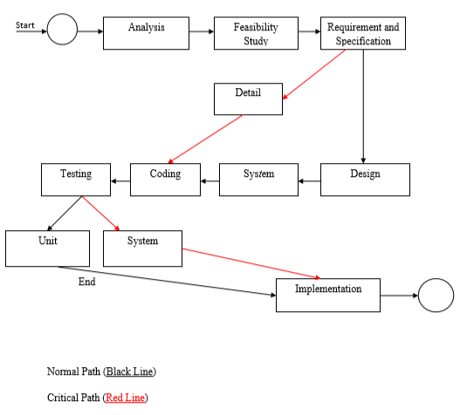

Figure – 3.5.1

### **3.5.2. Gantt chart:-**

We estimated the number of days for each task as follows:

**Table:-**

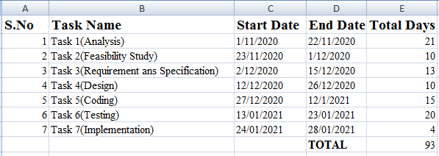

Fig – 3.5.2(i)

**3.5.3. Pivot Chart:-** 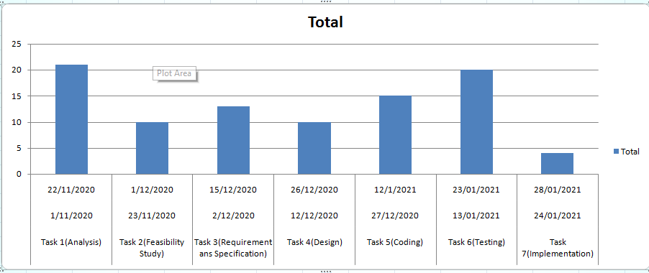

### 

Fig – 3.5.3(ii)

**3.6** **SOFTWARE REQUIREMENTS SPECIFICATION**

**Introduction**

The following subsections of the SRS document provide an overview of three tire SRS.

1. **Purpose**

The purpose of the project is to provide facility to the teacher as well as to the user to give exam online with better speed and fast results.

**B. Scope**

This website will be used by teacher as well as user to take exam anytime and for user to give exam remotely from anywhere.

**C. Benefits**

This application reduces the complexity, increase efficiency, increases accessibility and saving time.

### **3.6.1 Functional Requirement:-**

For this project we need the following functional requirement to be fulfilled:

* Login form that will allow the authorized user to access the software.
* We need to provide the facility to update , add and delete Questions for the teacher who wants to take the test.
* We need to provide the facility to the user to give exam and check results.

### **3.6.2 Non-Functional Requirement**

* The software needs to be user friendly and easy to access so that the end user can easily use this software.
* The software needs to be secure by implementing login using user ID and Password.
* The software needs to be portable so that it can be run on any system.

## Software Engineering Paradigm applied:-

* The software engineering paradigm applied in the system is the Iterative waterfall model.
* Firstly, the requirement of the system was analyzed, what was needed to build the proposed system, what were the initial requirements of the system was determined.
* Like, we need software that can be accessed easily on any system.
* All the requirements were already clearly specified what all functionalities needed to be provided like manage product and billing for an event.
* Using Iterative waterfall model a schedule can be set with deadlines for each stage of development like Information Gathering, Analysis, system design, coding, etc. and a system can proceed through the development process model phases one by one. So, this would help in the development of the system in the scheduled time.
* Then the system was designed on the basis of the requirement determined in the analysis phase.
* The design includes the different menus and options that will be displayed to the admin for performing different tasks.
* The Admin section of the project needs to provide the facility to show the record of question and user.
* Then we designed the database and the front end.

**TOOLS/PLATFORM USED**

## Hardware being used:

* **RAM**: 4 GB RAM
* **PROCESSOR**: Intel Core i3
* **HARD DISK**: 1TB Hard Disk

## Software being used:

* **OPERATING SYSTEM**: WINDOWS 8/10
* **FRONT END**: HTML.
* **BACK END/ DATABASE**: PHP, MY SQL

## Hardware minimum requirement:

* **RAM**: 4 GB RAM
* **PROCESSOR**: Intel® Pentium ® Dual CPU E2180
* **HARD DISK**: 160GB Hard Disk

## Software minimum requirement:

* **OPERATING SYSTEM**: WINDOWS 7 Ultimate
* **Browser**: Google Chrome, Mozilla Firefox or any browser.

### **3.8. Data Models**

**3.8.1. UML**

### **Use Case Diagram:-**

### 

Figure – 3.8(i)

**Activity Diagram:-**

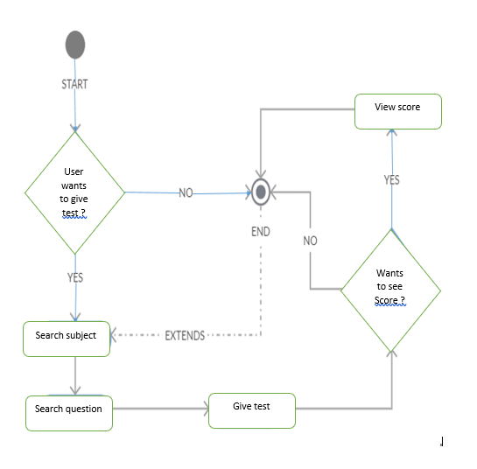

Figure – 3.8(ii)

**3.8.1 Class Diagram: -**

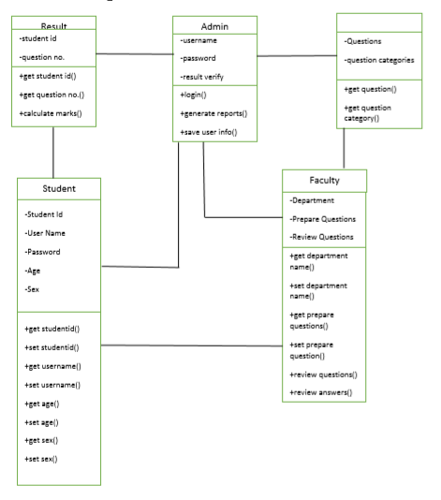

Figure – 3.8(iii)

**4. SYSTEM DESIGN**

* 1. **Modularization details:**

**4.1.1. User:**

* Login.
* Signup.
* Give test.
* View results.

**4.1.2. Admin:**

* Manage users.
* View user details.
* Update questions
* Delete questions.
* Manage results.
* User Login page:

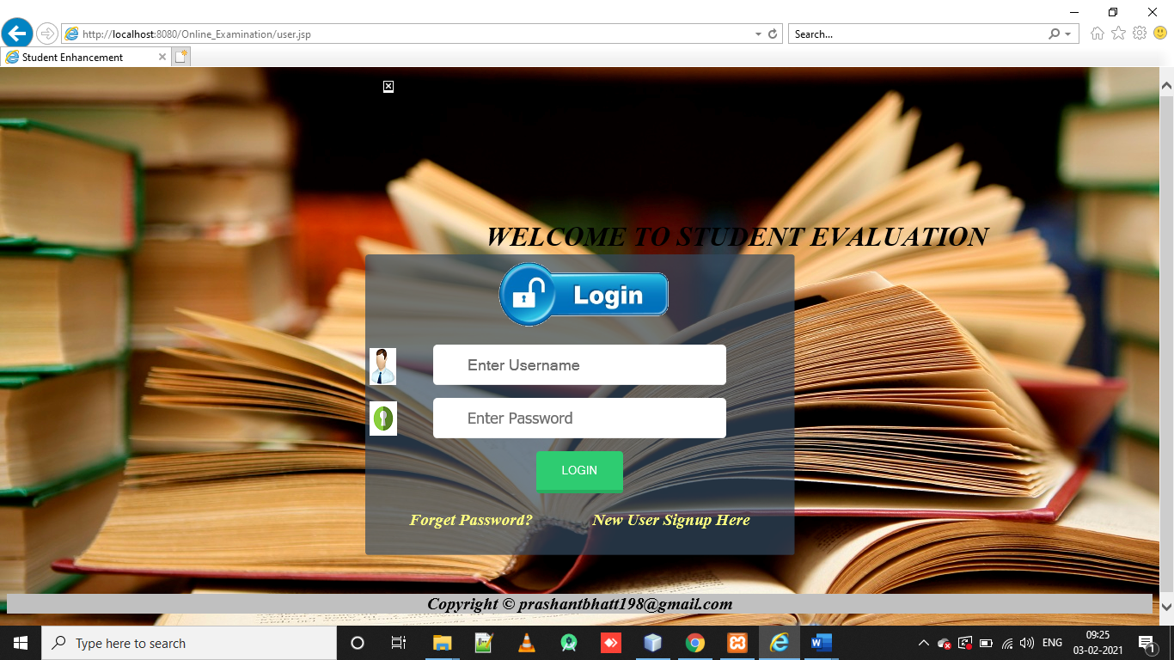

* User Signup Page:

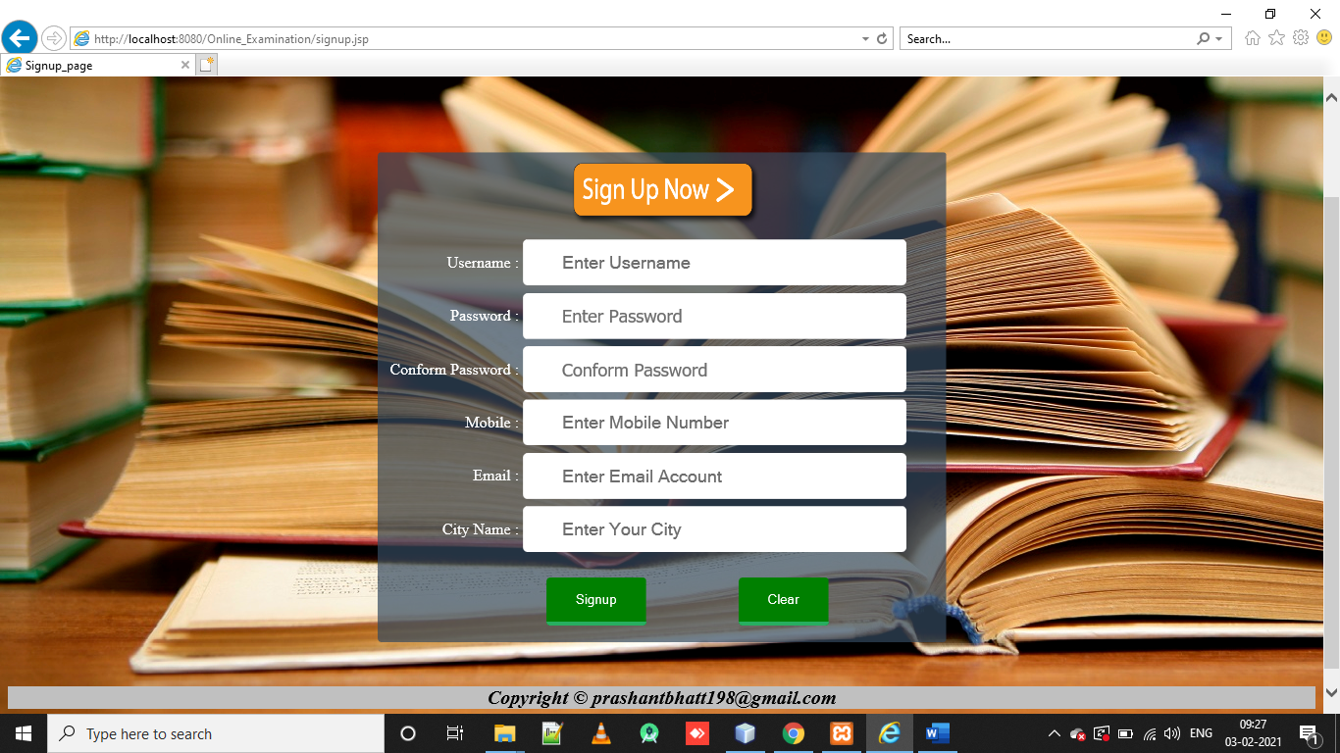

* Forgot Password page:

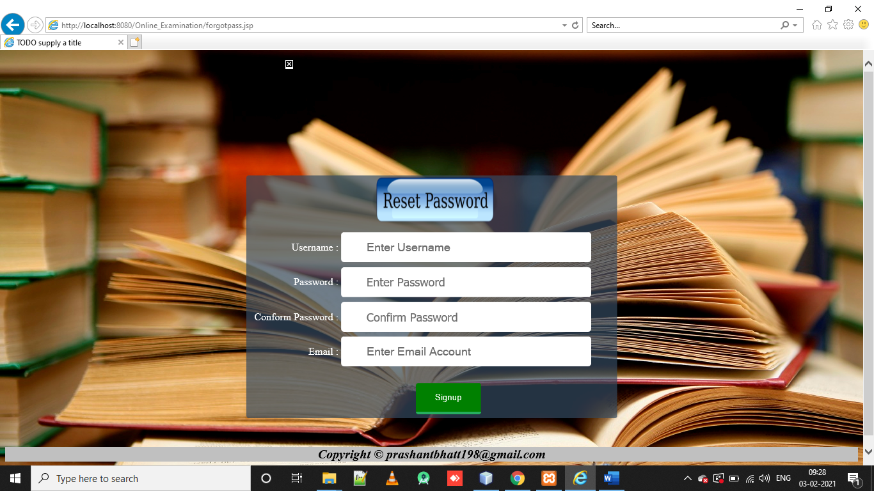

* Home page of User:

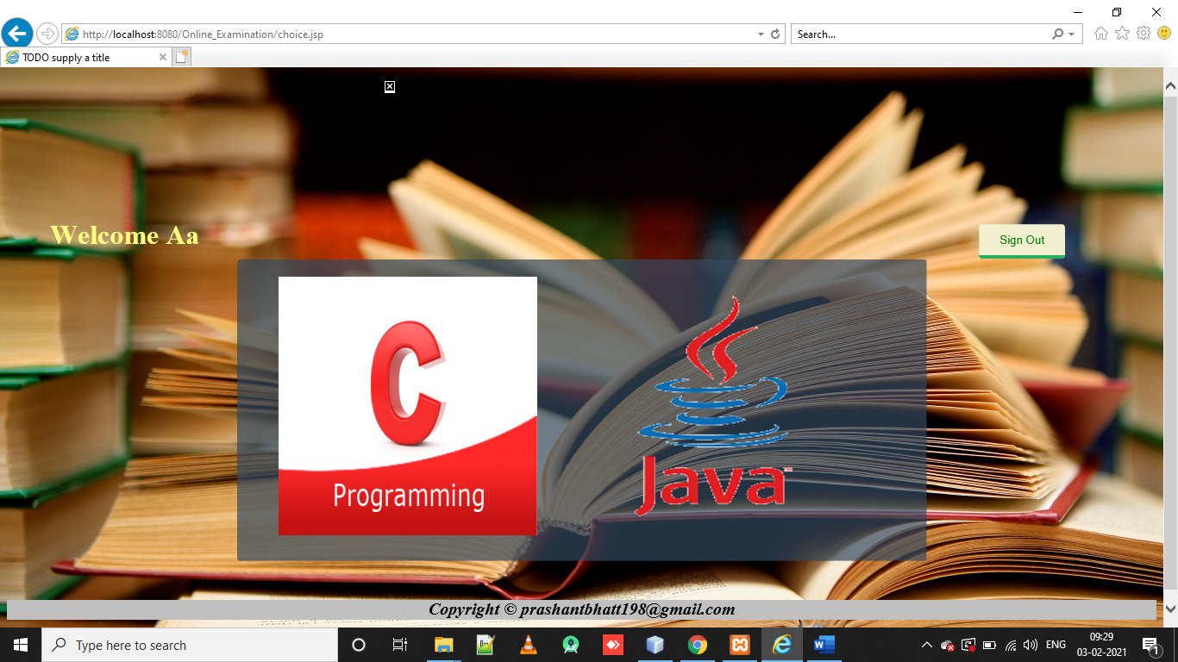

* Quiz Start page:

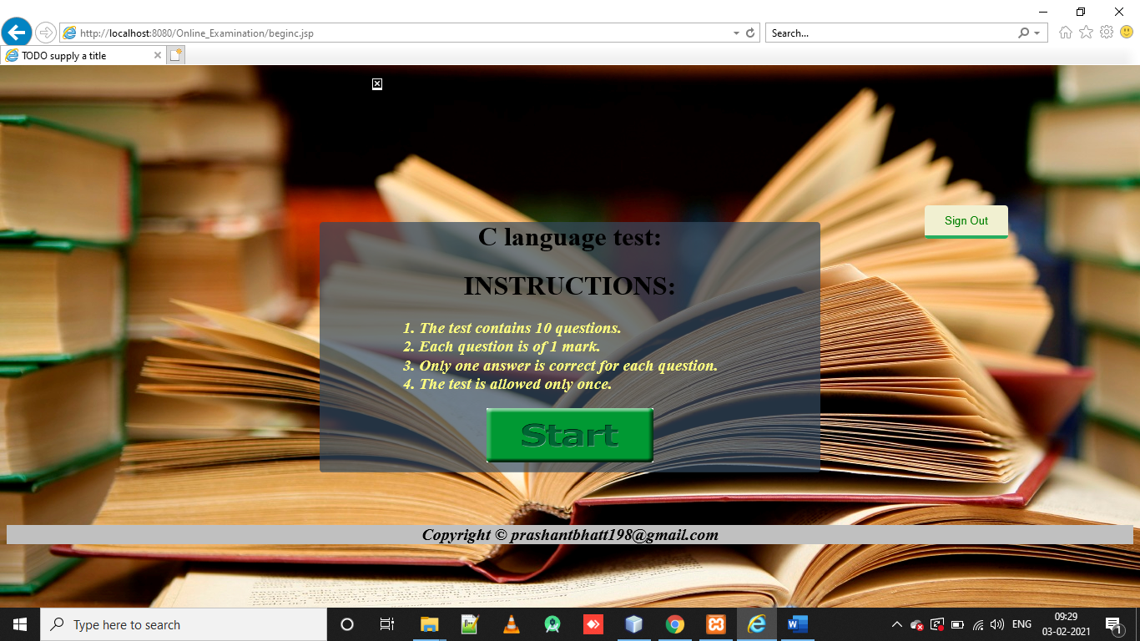

* Questions page:

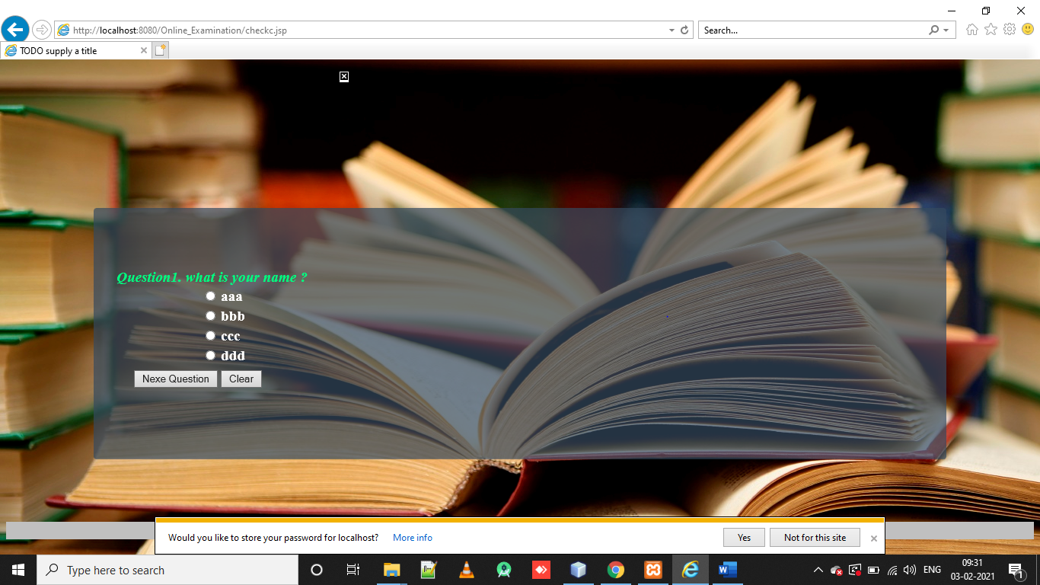

* **Admin Login:**

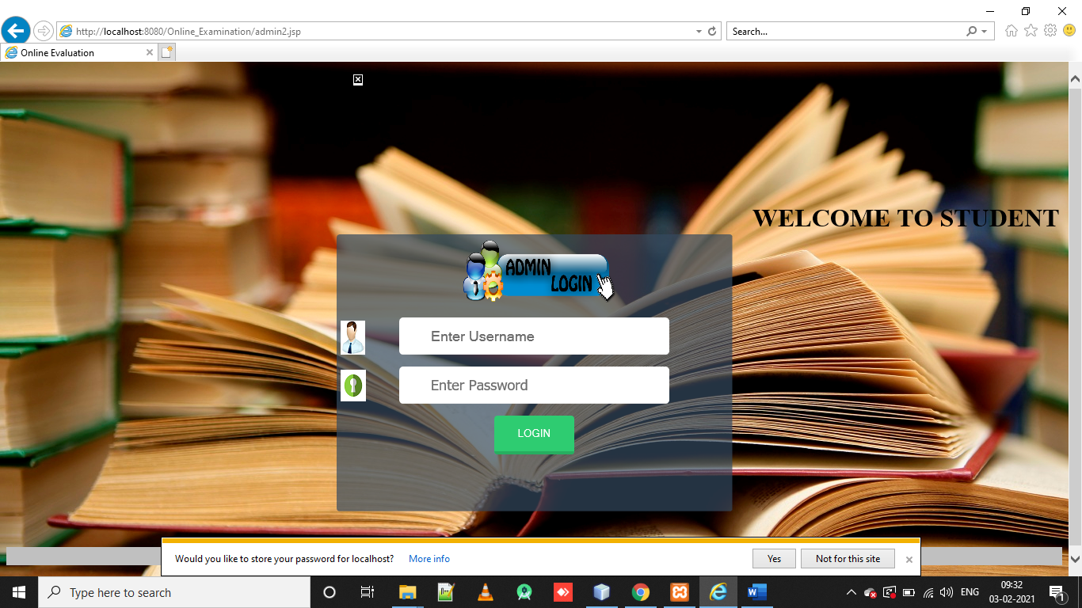

* **Admin Home page:**

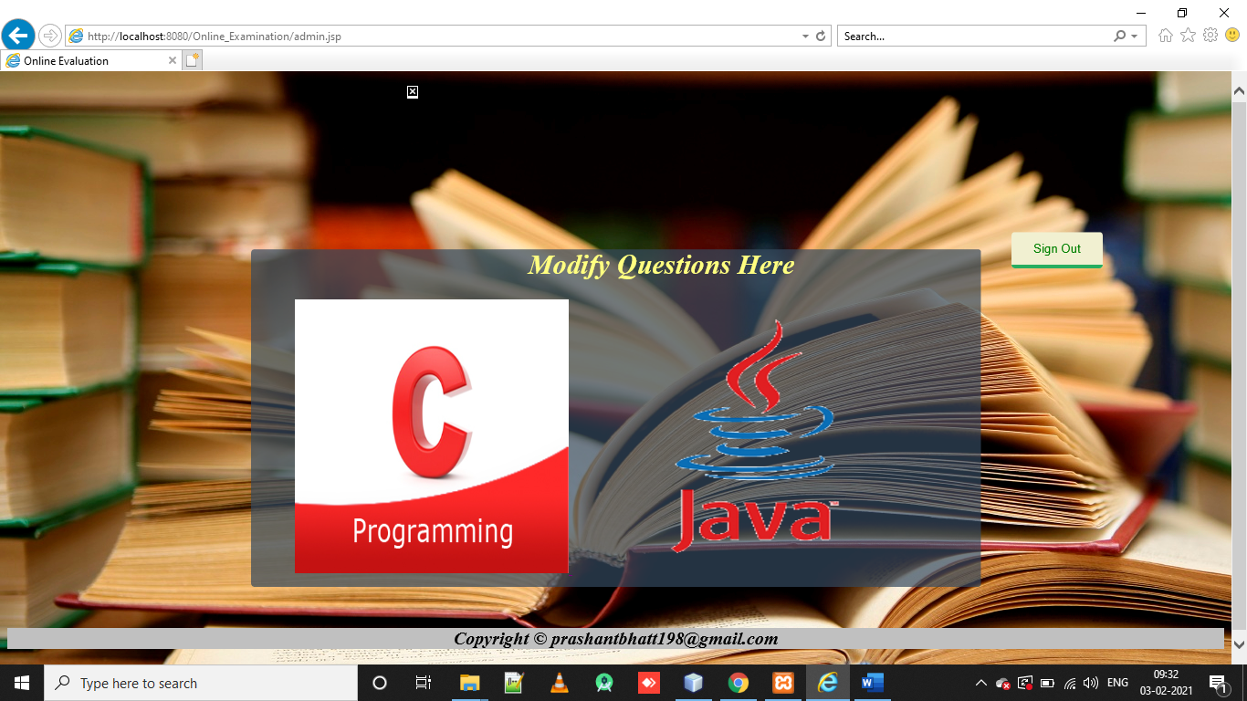

* **Modify Questions Page:**

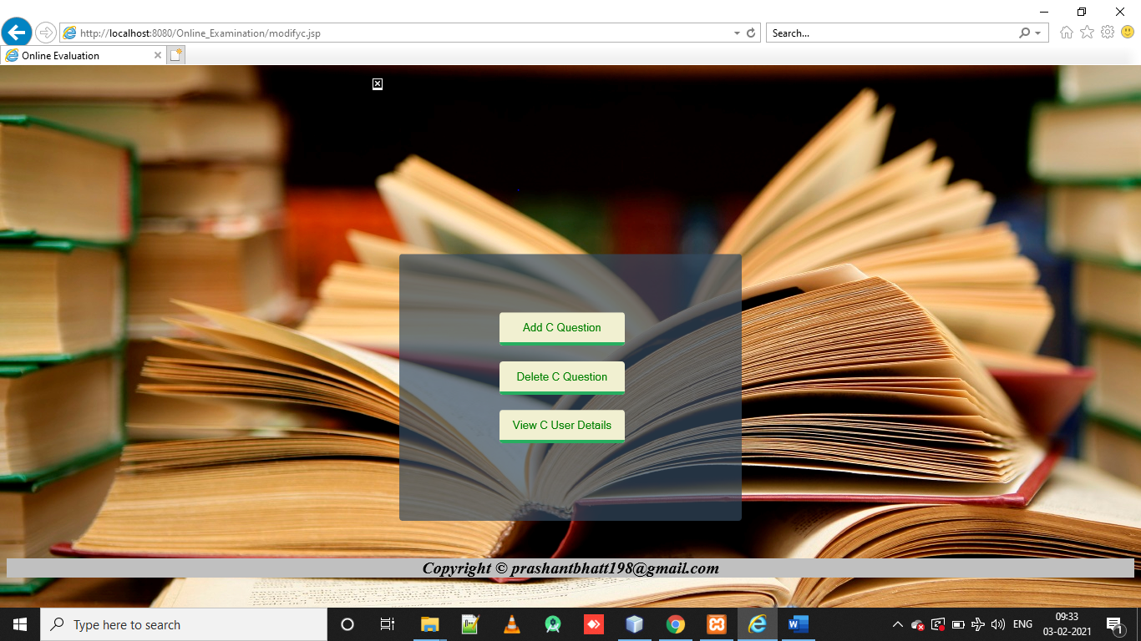

**4.1.3. Database:**

.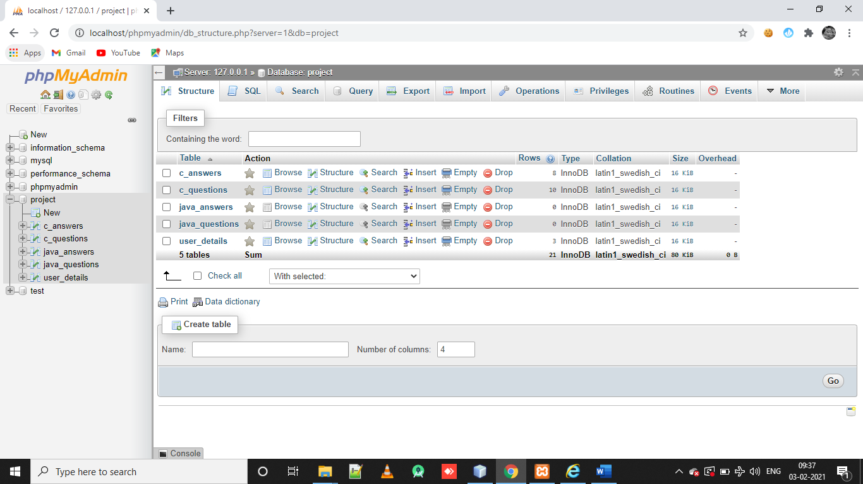

* User Table:

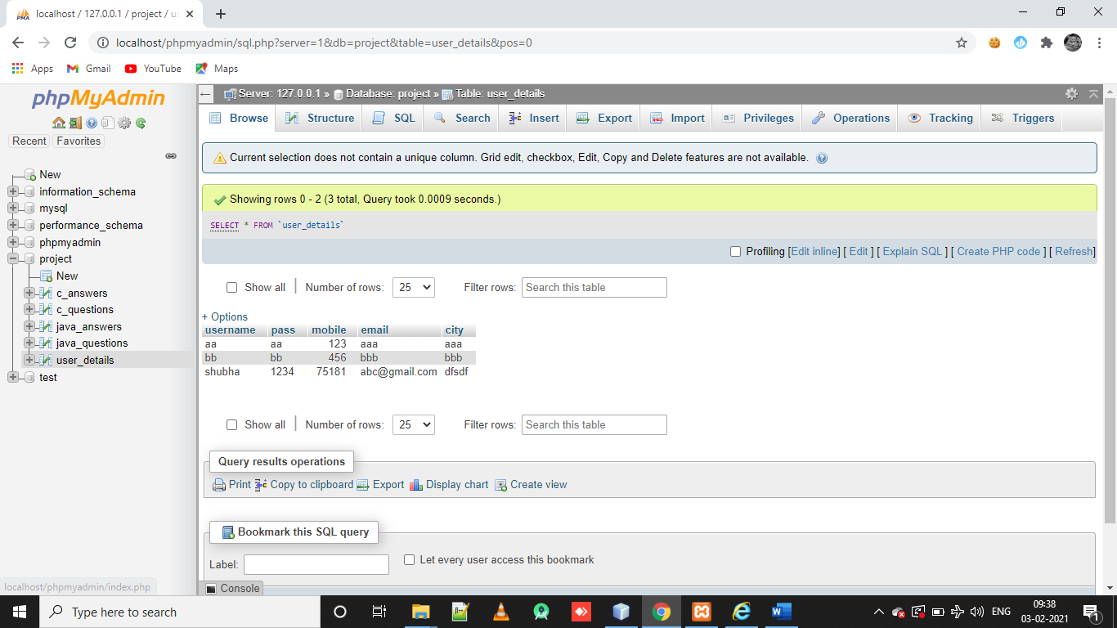

* Questions Page:

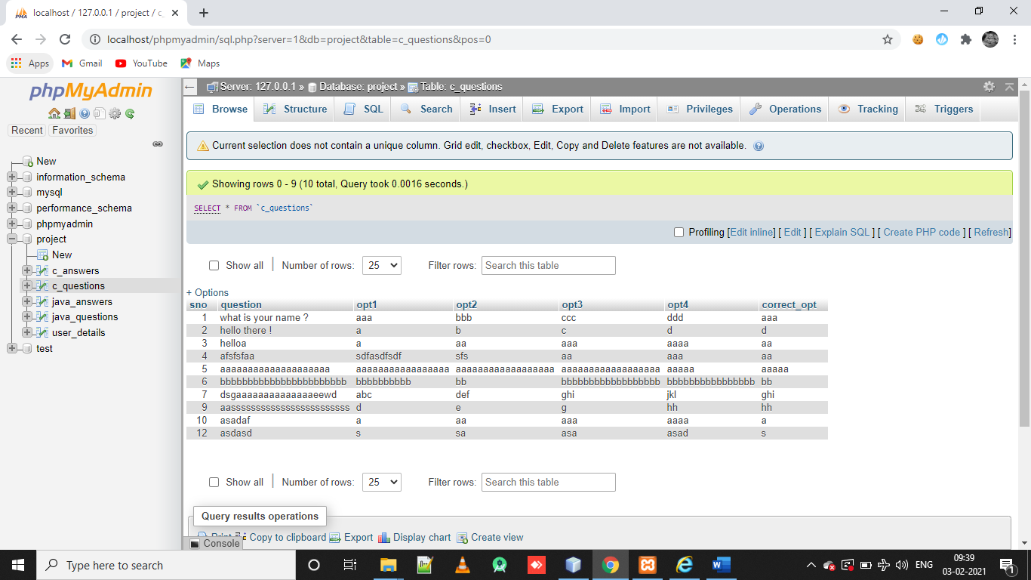

## 4.2 Data Integrity and Constraints

The integrity of the data in the database is maintained through constraints. There as many types of constraint on the attributes of the tables. For example, each table in the database has its primary key that has constraint NOT NULL and is ‘auto increment’ so that it generates automatically. Every related table is assigned with a foreign key to check the relation.

**VALIDATION AND CONSTRAINTS:-**

* **If you do not input any value then an error will be generated in the login form:**

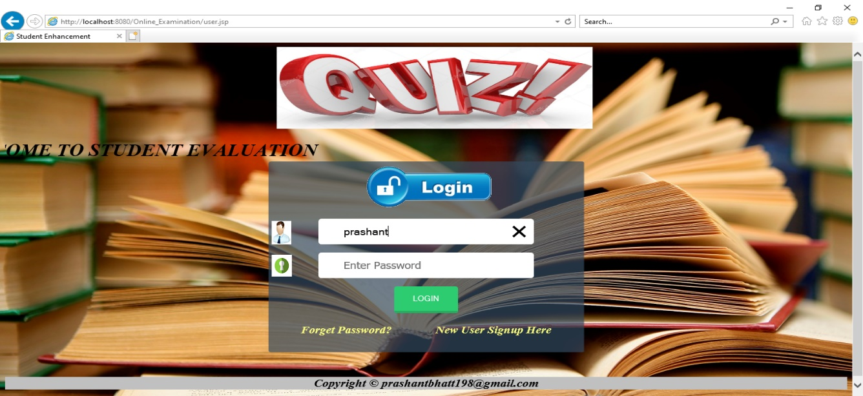

* **If you do not sign in can you still open home page?**

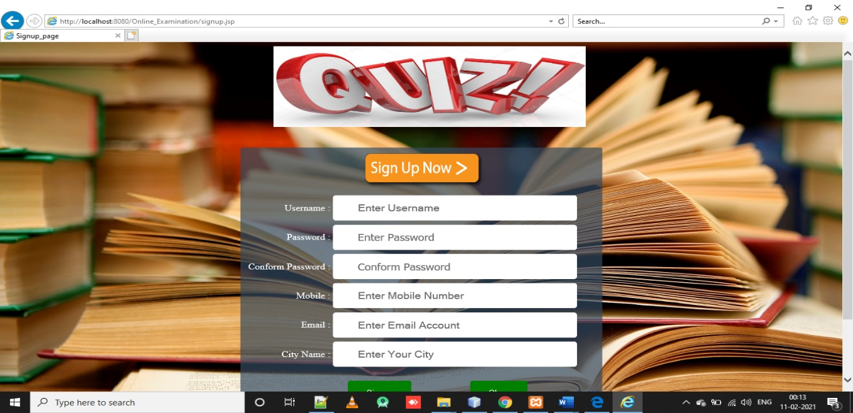

**5. TESTING**

**Testing Techniques and Testing Reports**

* **Unit Testing**:-

Unit testing, also known as component testing refers to tests that verify the functionality of a specific section of code, usually at the function level. In an object-oriented environment, this is usually at the class level, and the minimal unit tests include the constructors and destructors.

These types of tests are usually written by developers as they work on code (white-box style), to ensure that the specific function is working as expected. One function might have multiple tests, to catch [corner cases](http://en.wikipedia.org/wiki/Corner_case) or other branches in the code. Unit testing alone cannot verify the functionality of a piece of software, but rather is used to ensure that the building blocks of the software work independently from each other.

Unit testing is a software development process that involves synchronized application of a broad spectrum of defect prevention and detection strategies in order to reduce software development risks, time, and costs. It is performed by the software developer or engineer during the construction phase of the software development lifecycle. Rather than replace traditional QA focuses, it augments it. Unit testing aims to eliminate construction errors before code is promoted to QA; this strategy is intended to increase the quality of the resulting software as well as the efficiency of the overall development and QA process.

Depending on the organization's expectations for software development, unit testing might inc[lude static code analysis,](http://en.wikipedia.org/wiki/Static_code_analysis) data flow analysis, metrics analysis, peer code reviews, code coverage analysis and other software verification practices.

* **Software Testing**:-

The importance of software testing and its implication with respect to the software quality cannot be overemphasized. Error may occur at the very inception of the process, where the objectives may be erroneously or imperfectly specified, as well as in the design and development stages. Because of human inability to perform and communicate with perfection, the software development is accompanied by a quality assurance activity.

**Testing Objectives:-**

* Testing is a process of executing a program with the intention of finding an error.
* A good test case is one that has a high probability of finding an as yet undiscovered error.
* A successful test is one that uncovers an as yet undiscovered error.
* Functionality of the entire module/forms.
* Validations for user input.
* Checking of the Coding standards to be maintained during coding.
* Testing the module with all the possible test data.
* Testing of the functionality involving all type of calculations etc.
* Commenting standard in the source files

## Test Case (1):-

**If the User Info entered is wrong.**



## Test Case (2):-

**If the Signup page is working or not.**



## Test Case (3):-

**If user can choose the subject.**



## Test Case (4):-

**If user can give exam.**



## Test Case (5):-

**If admin can upload questions.**

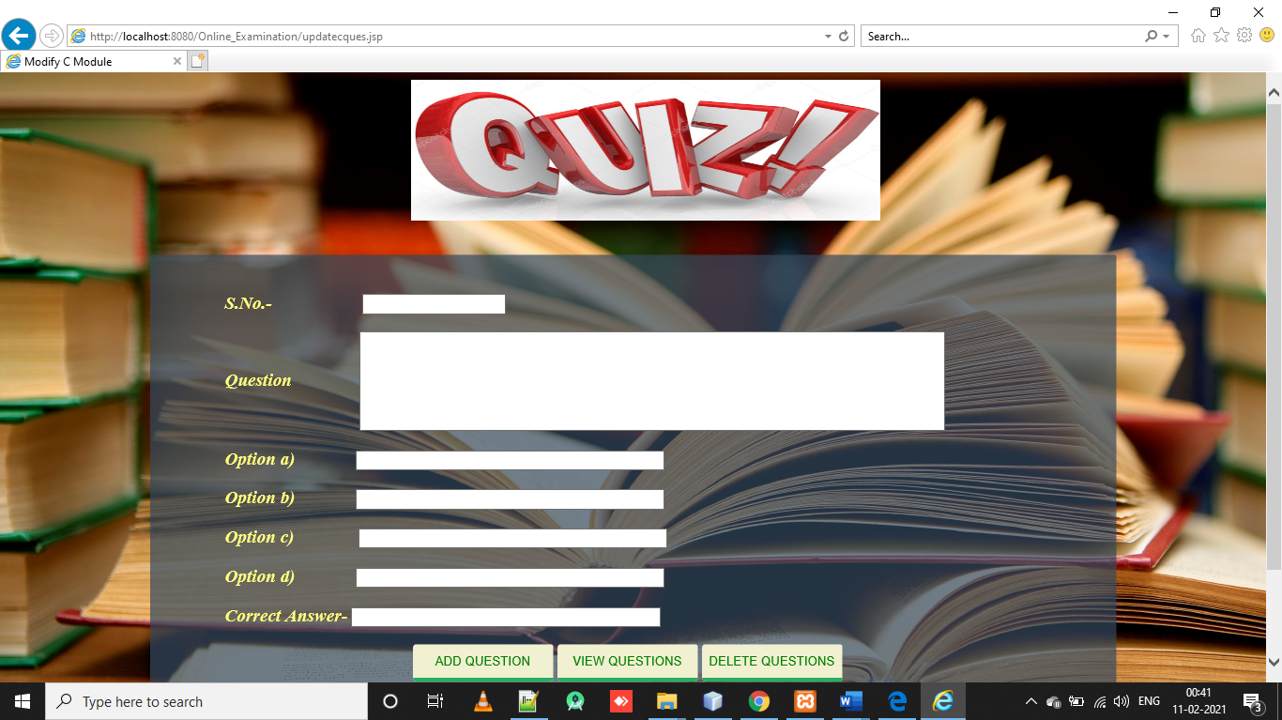

## Test Case (6):-

**If admin can search user.**



**6. SYSTEM SECURITY MEASURES**

Implementation of security for the developed project.

* Admin can change the password any time he/she wants.
* No one can add or delete records without the correct password of yours.

**7. COST ESTIMATION MODEL**

In Cocomo model two attributes are required:

1. Effort
2. Tdev(time development) First of all we calculate the Effort.

In our project we have estimated 5 KLOC(kilobyte line of code), two students are working on the project so our estimated cost would be

Effort (E) = a*(KLOC)*a2(where the value of a1 and a2 are constant i.e. 2.4 and 1.05) E=2.4*(5)*1.05

E=12.6

Now we have to calculate Tdev

Tdev(t) = b1*(E)*b2(where the value of b1 is 2.5 and b2 is 0.38) T=2.5*(12.6)*0.38

T=11.97

Now finally we calculate the estimated cost i.e. T * Cost of one employee Estimated Cost = T * Cost of one employee

= 11.97 * 1000

= =11,970

**8. Future scope**

This is a modern era of technology where everything becomes online. Internet is connecting more people at a faster rate ever before. Constant technological development leads to a rapid expansion of education sector.

In future we will expand this quiz application to take examination, assignments and much more to decrease manual work and take everything online.

**9. APPENDICES:-**

**9.1 Coding-**

**Connect file.java-**

package db;

import java.sql.Connection;

import java.sql.DriverManager;

public class Connect_File

{

public static Connection getConnection() throws Exception{

Class.forName("com.mysql.jdbc.Driver");

//get the object of connection interface

Connection con=DriverManager.getConnection("jdbc:mysql://localhost:3306/project","root","");

return con;

}

}

**Admin2.jsp-**

<!DOCTYPE html>

<html>

<head>

<title>Online Evaluation</title>

<meta charset="UTF-8">

<meta name="viewport" content="width=device-width, initial-scale=1.0">

<LINK rel="stylesheet" type="text/css" href="login.css"></LINK>

</head>

<body background="book.jpg">

<img src="logo.jpg" width="500" height="150" align="middle" style="margin-left:430px;">

<marquee><h1>WELCOME TO STUDENT EVALUATION</h1></marquee>

<DIV class="container">

<img alt="ulogin" src="admin-login.png">

<form action="adminlogin" method="post">

<DIV class="form-input">

<INPUT type="text" name="user_admin" placeholder="Enter Username" class="get"/>

</DIV>

<DIV class="form-input1">

<INPUT type="password" name="pass_admin" placeholder="Enter Password" class="get"/>

</DIV>

<DIV>

<INPUT type="submit" name="submit" value="LOGIN" class="btn-login" /><br />

</DIV>

</form>

</DIV>

</body>

<%@include file="foot.jsp" %>

</html>

**Beginc.jsp-**

<%

if (session.getAttribute("name") == null) {

response.sendRedirect("user.jsp");

}

%>

<%@page import="java.sql.*"%>

<%@include file="head.jsp"%>

<html>

<head>

<style type="text/css">

.container {

width: 600px;

height: 300px;

background-color: rgba(52, 73, 94, 0.7);

border-radius: 4px;

margin: 0 auto;

margin-top: -60px;

}

.signout {

color: green;

background: #F1F0D1;

padding-top: 5px;

padding-right: 5px;

padding-bottom: 5px;

padding-left: 5px;

border-radius: 4px;

border: none;

border-bottom: 4px solid #27aE60;

cursor: pointer;

height: 40px;

width: 100px;

margin-left: 1100px;

margin-top: -30px;

}

.text{

color:#ffff80;

font-style:oblique;

font-size:1.2em;

padding-left:100px;

}

</style>

</head>

<body>

<form action="userlogout">

<input type="submit" class="signout" value="Sign Out"><br>

<br>

</form>

<div class="container">

<h1 style="text-align: center;">C language test:</h1>

<h1 style="text-align: center;">INSTRUCTIONS:</h1>

<b class="text">1. The test contains 10 questions.</b><br>

<b class="text">2. Each question is of 1 mark.</b><br>

<b class="text">3. Only one answer is correct for each question.</b><br>

<b class="text">4. The test is allowed only once.</b><br><br>

<a href="checkc.jsp" style="margin-left:200px;"><img src="start.jpg" width="200" height="65"></a>

</div>

<br>

<%@include file="foot.jsp"%>

</body>

</html>

**Beginjava.jsp-**

<%

if (session.getAttribute("name") == null) {

response.sendRedirect("user.jsp");

}

%>

<%@page import="java.sql.*"%>

<%@include file="head.jsp"%>

<html>

<head>

<style type="text/css">

.container {

width: 600px;

height: 300px;

background-color: rgba(52, 73, 94, 0.7);

border-radius: 4px;

margin: 0 auto;

margin-top: -60px;

}

.signout {

color: green;

background: #F1F0D1;

padding-top: 5px;

padding-right: 5px;

padding-bottom: 5px;

padding-left: 5px;

border-radius: 4px;

border: none;

border-bottom: 4px solid #27aE60;

cursor: pointer;

height: 40px;

width: 100px;

margin-left: 1100px;

margin-top: -30px;

}

.text{

color:#ffff80;

font-style:oblique;

font-size:1.2em;

padding-left:100px;

}

</style>

</head>

<body>

<form action="userlogout">

<input type="submit" class="signout" value="Sign Out"><br>

<br>

</form>

<div class="container">

<h1 style="text-align: center;">C language test:</h1>

<h1 style="text-align: center;">INSTRUCTIONS:</h1>

<b class="text">1. The test contains 10 questions.</b><br>

<b class="text">2. Each question is of 1 mark.</b><br>

<b class="text">3. Only one answer is correct for each question.</b><br>

<b class="text">4. The test is allowed only once.</b><br><br>

<a href="checkc.jsp" style="margin-left:200px;"><img src="start.jpg" width="200" height="65"></a>

</div>

<br>

<%@include file="foot.jsp"%>

</body>

</html>

**Checkjava.jsp-**

<%@page import="java.sql.Connection"%>

<%@page import="db.Connect_File"%>

<%

if(session.getAttribute("name")==null){

response.sendRedirect("user.jsp");

}

%>

<!DOCTYPE html>

<%@page import="java.util.ArrayList, beans.*"%>

<%@page import="java.sql.*"%>

<html>

<%@include file="head.jsp" %>

<title>C Quiz</title>

<body background="im.jpg">

<b>

<a href="choice.jsp"><input type="button" value="Home" style="color:green;background:#F1F0D1;padding-top:5px;padding-right:5px;padding-bottom:5px;padding-left:5px;border-radius:4px;border:none;border-bottom:4px solid #27aE60;cursor:pointer;height:40px;width:100px;margin-right:30px; "></a>

<a href="viewjavaresult.jsp"><input type="button" value="View Result" style="color:green;background:#F1F0D1;padding-top:5px;padding-right:5px;padding-bottom:5px;padding-left:5px;border-radius:4px;border:none;border-bottom:4px solid #27aE60;cursor:pointer;height:40px;width:100px; "> </a><br><br><br>

<%

String s=(String)session.getAttribute("email");

Connection conn=Connect_File.getConnection();

String query2="select * from java_answers where email=?";

PreparedStatement ps=conn.prepareStatement(query2);

PreparedStatement ps2=conn.prepareStatement("select * from java_questions order by sno");

ps.setString(1,s);

ResultSet rs=ps.executeQuery();

if ( rs.next()){

out.println("Not allowed. You have already given the test.");

conn.close();

}

else{

ResultSet rs2=ps2.executeQuery();

java.util.ArrayList list=new java.util.ArrayList();

while(rs2.next()) {

Question q=new Question();

q.setSno(rs2.getInt(1));

q.setQuestion(rs2.getString(2));

q.setAns1(rs2.getString(3));

q.setAns2(rs2.getString(4));

q.setAns3(rs2.getString(5));

q.setAns4(rs2.getString(6));

q.setCorrect(rs2.getString(7));

list.add(q);

}

session.setAttribute("dbdata",list);

conn.close();

%>

<jsp:forward page="javaques.jsp"></jsp:forward>

<%

}

%>

</b>

<br><br><br><br><br><br><br><br><br><br><br><br><br><br><br><br>

<%@include file="foot.jsp" %>

</body>

</html>

**Datasave.jsp-**

<%@page import="db.Connect_File"%>

<%@page import="java.sql.*"%>

<%@include file="head.jsp" %>

<html>

<body background="im.jpg">

<%

String u=request.getParameter("user");

String p=request.getParameter("pass");

String p1=request.getParameter("pass1");

String m=request.getParameter("mobile");

String e=request.getParameter("email");

String c=request.getParameter("city");

Connection conn=Connect_File.getConnection();

String query="insert into user_details values(?,?,?,?,?)";

PreparedStatement ps=conn.prepareStatement(query);

if(p.equals(p1)){

ps.setString(1,u);

ps.setString(2,p);

ps.setString(3,m);

ps.setString(4,e);

ps.setString(5,c);

ps.executeUpdate();

conn.close();

}else{

session.setAttribute("reply","Something Wrong Please Signup Again");

response.sendRedirect("signup.jsp");

}

%>

</body>

<jsp:forward page="user.jsp"/>

<%@include file="foot.jsp" %>

</html>

**Deleteque.jsp-**

<%@page import="db.Connect_File"%>

<%@page import="java.sql.*"%>

<%@include file="head.jsp" %>

<!DOCTYPE html>

<html>

<head>

<title>Modify C database</title>

<style type="text/css">

.container {

width: 950px;

height: 1800px;

padding-left:80px;

padding-top:40px;

background-color: rgba(52, 73, 94, 0.7);

border-radius: 4px;

margin: 0 auto;

margin-top: 18px;

}

.signout {

color: green;

background: #F1F0D1;

padding-top: 5px;

padding-right: 5px;

padding-bottom: 5px;

padding-left: 5px;

border-radius: 4px;

border: none;

border-bottom: 4px solid #27aE60;

cursor: pointer;

height: 40px;

width: 150px;

margin-left: 210px;

}

.text{

color:#ffff80;

font-style:oblique;

font-size:1.2em;

}

</style>

</head>

<body>

<%

Connection conn=Connect_File.getConnection();

String query="select * from c_questions";

PreparedStatement ps=conn.prepareStatement(query);

ResultSet rs=ps.executeQuery();

%>

<div class="container">

<h2 style="color:#ffff80;text-align: center;">C questions database:</h2>

<%

while (rs.next()){

String sno=rs.getString("sno");

String ques=rs.getString("question");

String a=rs.getString("opt1");

String b=rs.getString("opt2");

String c=rs.getString("opt3");

String d=rs.getString("opt4");

String correct=rs.getString("correct_opt");

%>

<b class="text">Question <%=sno%>: <%=ques%></b><br>

<b class="text">a) <%=a%></b><br>

<b class="text">b) <%=b%></b><br>

<b class="text">c) <%=c%></b><br>

<b class="text">d) <%=d%></b><br>

<b class="text">Correct Choice: <%=correct%></b><br><br>

<%

}

conn.close();

%>

<fieldset style="width: 600px; margin-left: 150px;">

<form action="dcq.jsp" method="post"><br>

<b class="text">Enter the question number you wish to delete:</b>

&nbsp;&nbsp;&nbsp;&nbsp;<input type="text" name="delete"><br>

<br>

<input type="submit" value="Delete" class="signout">

<br><br>

</form>

</fieldset>

</div>

<%@include file="foot.jsp" %>

</body>

</html>

**Foot.jsp-**

<!DOCTYPE html>

<html>

<head>

<title>TODO supply a title</title>

<meta charset="UTF-8">

<meta name="viewport" content="width=device-width, initial-scale=1.0">

</head>

<body>

<p style="text-align: center; font-size: 20px; margin-top:45px;background-color:silver;">

<b><i>Copyright © prashantbhatt198@gmail.com</i></b>

</p>

</body>

</html>

**Forgotpass.jsp-**

<!DOCTYPE html>

<html>

<head>

<title>TODO supply a title</title>

<meta charset="UTF-8">

<meta name="viewport" content="width=device-width, initial-scale=1.0">

</head>

<body>

<p style="text-align: center; font-size: 20px; margin-top:45px;background-color:silver;">

<b><i>Copyright © prashantbhatt198@gmail.com</i></b>

</p>

</body>

</html>

**Head.jsp-**

<%@page errorPage="error.jsp" %>

<!DOCTYPE html>

<html>

<head>

<meta charset="UTF-8">

<meta name="viewport" content="width=device-width, initial-scale=1.0">

</head>

<body background="book.jpg">

<img src="logo.PNG" width="500" height="150" align="middle" style="margin-left:430px;"><br><br>

</body>

</html>

**Signup.jsp-**

<%@ include file="head.jsp" %>

<!DOCTYPE HTML>

<HEAD>

<TITLE>Signup_page</TITLE>

<LINK rel="stylesheet" type="text/css" href="signup.css"></LINK>

</HEAD>

<BODY>

<DIV class="container">

<img alt="signup" src="Sign-up.png" height="80px;" width="200px;">

<form action="data_save.jsp" method="post">

<TABLE>

<TR>

<TD><p class="pera">Username :</p></TD>

<TD>

<DIV class="form-input">

<INPUT type="text" name="user" placeholder="Enter Username" class="get">

</DIV>

</TD>

</TR>

<TR><TD><p class="pera">Password :</p></TD>

<TD>

<DIV class="form-input">

<INPUT type="password" name="pass" placeholder="Enter Password">

</DIV>

</TD>

</TR>

<TR><TD><p class="pera">Conform Password :</p></TD>

<TD>

<DIV class="form-input">

<INPUT type="password" name="pass1" placeholder="Conform Password">

</DIV>

</TD>

</TR>

<TR><TD><p class="pera">Mobile :</p></TD>

<TD>

<DIV class="form-input">

<INPUT type="number" name="mobile" placeholder="Enter Mobile Number">

</DIV>

</TD>

</TR>

<TR><TD><p class="pera">Email :</p></TD>

<TD>

<DIV class="form-input">

<INPUT type="text" name="email" placeholder="Enter Email Account">

</DIV>

</TD>

</TR>

<TR><TD><p class="pera">City Name :</p></TD>

<TD>

<DIV class="form-input">

<INPUT type="text" name="city" placeholder="Enter Your City">

</DIV>

</TD>

</TR>

<TR><TD colspan="2">

<INPUT type="submit" name="submit" value="Signup" class="btn-signup">

<INPUT type="reset" name="clear" value="Clear" class="btn-clear">

</TD>

</TR>

</TABLE>

</form>

</DIV>

<%@ include file="foot.jsp"%>

**User.jsp-**

<!DOCTYPE html>

<html>

<head>

<LINK rel="stylesheet" type="text/css" href="login.css"></LINK>

<title>Student Enhancement</title>

<meta charset="UTF-8">

<meta name="viewport" content="width=device-width, initial-scale=1.0">

</head>

<body background="book.jpg">

<img src="logo.PNG" width="500" height="150" align="middle" style="margin-left:430px;">

<marquee>

<h1><b><i>WELCOME TO STUDENT EVALUATION</i></b></h1>

</marquee>

<DIV class="container">

<img alt="ulogin" src="button.png">

<form action="userlogin" method="post">

<DIV class="form-input">

<INPUT type="text" name="user" placeholder="Enter Username" class="get"/>

</DIV>

<DIV class="form-input1">

<INPUT type="password" name="pass" placeholder="Enter Password" class="get"/>

</DIV>

<DIV>

<INPUT type="submit" name="submit" value="LOGIN" class="btn-login" /><br />

</DIV>

<DIV>

<A href="forgotpass.jsp" class="a1"><b>Forget Password?</b> </A>

<A href="signup.jsp" class="a2"><b>New User Signup Here</b></A>

</DIV>

</form>

</DIV>

</body>

</html>

<%@include file="foot.jsp"%>

**Question.jsp-**

<%@page import="db.Connect_File"%>

<%@page import="java.sql.*"%>

<%@include file="head.jsp" %>

<!DOCTYPE html>

<html>

<head>

<title>Modify C database</title>

<style type="text/css">

.container {

width: 950px;

height: 1800px;

padding-left:80px;

padding-top:40px;

background-color: rgba(52, 73, 94, 0.7);

border-radius: 4px;

margin: 0 auto;

margin-top: 18px;

}

.signout {

color: green;

background: #F1F0D1;

padding-top: 5px;

padding-right: 5px;

padding-bottom: 5px;

padding-left: 5px;

border-radius: 4px;

border: none;

border-bottom: 4px solid #27aE60;

cursor: pointer;

height: 40px;

width: 150px;

margin-left: 210px;

}

.text{

color:#ffff80;

font-style:oblique;

font-size:1.2em;

}

</style>

</head>

<body>

<%

Connection conn=Connect_File.getConnection();

String query="select * from c_questions";

PreparedStatement ps=conn.prepareStatement(query);

ResultSet rs=ps.executeQuery();

%>

<div class="container">

<h2 style="color:#ffff80;text-align: center;">C questions database:</h2>

<%

while (rs.next()){

String sno=rs.getString("sno");

String ques=rs.getString("question");

String a=rs.getString("opt1");

String b=rs.getString("opt2");

String c=rs.getString("opt3");

String d=rs.getString("opt4");

String correct=rs.getString("correct_opt");

%>

<b class="text">Question <%=sno%>: <%=ques%></b><br>

<b class="text">a) <%=a%></b><br>

<b class="text">b) <%=b%></b><br>

<b class="text">c) <%=c%></b><br>

<b class="text">d) <%=d%></b><br>

<b class="text">Correct Choice: <%=correct%></b><br><br>

<%

}

conn.close();

%>

<a href="updatecques.jsp"><input type="button" value="Add Question" class="signout"></a><a href="deletecques.jsp"><input type="button" value="Delete Question" class="signout"></a>

</div>

<%@include file="foot.jsp" %>

</body>

</html>

**Viewresult.jsp-**

<%@page import="db.Connect_File"%>

<%

if(session.getAttribute("name")==null){

response.sendRedirect("user.jsp");

}

%>

<!DOCTYPE html>

<%@page import="java.sql.*"%>

<html>

<%@include file="head.jsp" %>

<head>

<title>Marks Details</title>

<style type="text/css">

.container{

width:950px;

height:auto;

background-color:rgba(52, 73, 94, 0.7);

border-radius:4px;

margin:0 auto;

padding-top:20px;

padding-bottom:20px;

}

.text{

color:#ffff80;

font-style:oblique;

font-size:1.2em;

padding-left:40px;

}

.text1{

color:#ffffff;

font-style:oblique;

font-size:1.3em;

padding-left:40px;

}

</style>

</head>

<body>

<a href="choice.jsp"><input type="button" value="Home" style="color:green;background:#F1F0D1;padding-top:5px;padding-right:5px;padding-bottom:5px;padding-left:5px;border-radius:4px;border:none;border-bottom:4px solid #27aE60;cursor:pointer;height:40px;width:100px;margin-right:30px; "></a>

<h2>Detailed result: </h2>

<br>

<br>

<%

String email=(String)session.getAttribute("email");

Connection conn=Connect_File.getConnection();

String query1="select *from c_questions";

String query2="select *from c_answers where email=? order by sno";

PreparedStatement ps1=conn.prepareStatement(query1);

PreparedStatement ps2=conn.prepareStatement(query2);

ps2.setString(1,email);

ResultSet rs1=ps1.executeQuery();

ResultSet rs2=ps2.executeQuery();

int cnum=0;

%>

<div class="container">

<%

while (rs1.next()&& rs2.next()){

String sno=rs1.getString("sno");

String ques=rs1.getString("question");

String a=rs1.getString("opt1");

String b=rs1.getString("opt2");

String c=rs1.getString("opt3");

String d=rs1.getString("opt4");

String correct=rs1.getString("correct_opt");

String userans=rs2.getString("userans");

if(correct.equals(userans)){

cnum++;

}

%>

<b class="text"> Question <%=sno%>: <%=ques%></b><br>

<b class="text"> a) <%=a%></b><br>

<b class="text"> b) <%=b%></b><br>

<b class="text"> c) <%=c%></b><br>

<b class="text"> d) <%=d%></b><br>

<b class="text"> Correct Answer: <%=correct%></b><br>

<b class="text1"> Your Answer: <%=userans%></b><br><br>

<%

}

out.println("<b class='text1'>Number of Correct Answers: "+cnum+"</b>");

%>

</div>

<%

conn.close();

%>

<%@include file="foot.jsp" %>

</body>

</html>

**Viewuser.jsp-**

<!DOCTYPE html>

<%@page import="db.Connect_File"%>

<%@page import="java.sql.*"%>

<html>

<%@include file="head.jsp" %>

<a href="modifyc.jsp"><input type="button" value="Admin Home" class="signout"></a>

<head>

<title>Modify C database</title>

<style type="text/css">

.container {

width: 600px;

height: 2020px;

padding-left:20px;

background-color: rgba(52, 73, 94, 0.7);

border-radius: 4px;

margin: 0 auto;

margin-top: 40px;

}

.signout {

color: green;

background: #F1F0D1;

padding-top: 5px;

padding-right: 5px;

padding-bottom: 5px;

padding-left: 5px;

border-radius: 4px;

border: none;

border-bottom: 4px solid #27aE60;

cursor: pointer;

height: 40px;

width: 100px;

margin-left: 30px;

margin-top: -30px;

}

.text{

color:#ffff80;

font-style:oblique;

font-size:1.2em;

}

</style>

</head>

<body>

<%

String email=request.getParameter("email");

Connection conn=Connect_File.getConnection();

String query1="select * from c_questions";

String query2="select * from c_answers where email=?";

PreparedStatement ps1=conn.prepareStatement(query1);

PreparedStatement ps2=conn.prepareStatement(query2);

ps2.setString(1,email);

ResultSet rs1=ps1.executeQuery();

ResultSet rs2=ps2.executeQuery();

int cnum=0;

%>

<div class="container">

<b class="text">

<h2 style="text-align: center;">Detailed result: </h2>

<%

while (rs1.next()&& rs2.next()){

String sno=rs1.getString("sno");

String ques=rs1.getString("question");

String a=rs1.getString("opt1");

String b=rs1.getString("opt2");

String c=rs1.getString("opt3");

String d=rs1.getString("opt4");

String correct=rs1.getString("correct_opt");

String userans=rs2.getString("userans");

if(correct.equals(userans)){

cnum++;

}

%>

Question <%=sno%>: <%=ques%><br>

a) <%=a%><br>

b) <%=b%><br>

c) <%=c%><br>

d) <%=d%><br>

Correct Choice: <%=correct%><br>

User's Choice: <%=userans%><br><br>

<%

}

out.println("Number of correct answers: "+cnum);

conn.close();

%>

</b>

</div>

<%@include file="foot.jsp" %>

</body>

</html>

**9.2 Bibliography:-**

**Books**

[1]A.Troelsen, The Complete Reference for Pro HTML and the PHP Platform. Hill Edition, Pagano: - 123-135

[2]S. Holzner, Programming HTML, CSS: - 207-235

[3]C.Thomsen, Database Programming SQL, Second Edition

**Websites**

Topic: Navigation Design

[4]HTML Introduction” [www.codeproject.com](http://www.codeproject.com),( Last Access 1/10/2020 11:00pm)

[5]”Feasibilities”, http://en.wikipedia.org/wiki/Feasibility study,(Last Access 22/11/2020 10:22pm)

[6]”Functional Requirements”, [www.w3schools.com](http://www.w3schools.com) (Last Access 31/12/2020 10:00pm)